**Match the counters under the cup with the equations**

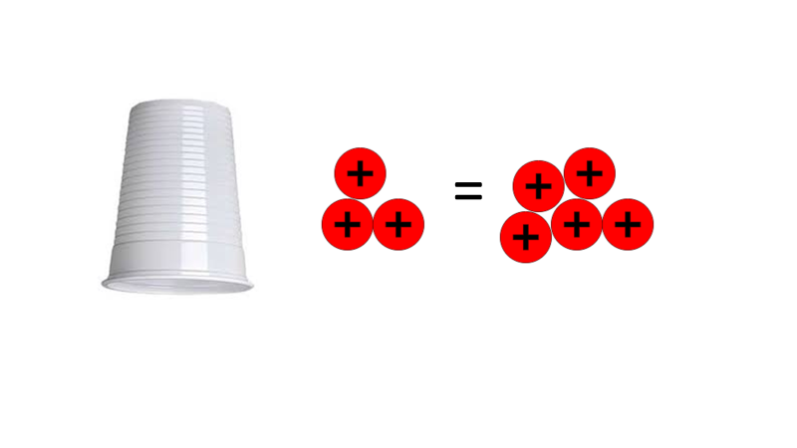

x + 3 = 1

x + 3 = -2

x + 3 = 5

x + 3 = 4

2

x + 3 = 8

x + 8 = 2

3

x + 3 = -1

x – 2 = 2

4

x + 5 = 3







  
  
  



  
  
  