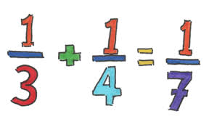

**The misconceptions the pupils will have, and how these can be cleared up**

**real-world (concrete) representation to introduce the concept**

key concept

**5 Minute Shanghai Plan**

**mathematical reasoning and discussions to take place in lesson**



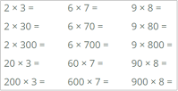**Intelligent practice** (Conceptual Variation, Procedural Variation)

(questions and problems) to give fluency and deep understanding

**connections**