Why are these Work Groups needed?
The Work Groups promote teaching for mastery approaches across the KS2-3 boundary to ensure consistency in the pupil experience thereby addressing strategic goals relevant to primary and secondary schools, specifically:

(primary) all pupils develop deep knowledge, understanding and confidence, and are well prepared for the secondary mathematics curriculum.

(secondary) working with schools to address specific challenges in secondary mathematics teaching through the use of teaching for mastery approaches in Year 5-8 continuity.

Ofsted¹ and EEF² publications have highlighted the need for a focus on continuity at transition from KS2-3 and their recommendations include improving knowledge and understanding of pedagogy and curriculum in the other key stage.

The work aims to avoid the dip in attainment which is often reported as pupils move from primary to secondary education. Over the past two years participation in this project has increased significantly, indicating a continued need for work in this area.

¹Key Stage 3 – the wasted years? (Ofsted, 2015)
²Improving mathematics in key stages 2 and 3 (EEF, 2017)

Year 5 to 8 Continuity
Work Groups in this project aim to strengthen the transition from primary to secondary school by focusing on curriculum and pedagogical continuity over Years 5 to 8.

Central to the Work Group is the promotion of cross phase communication between teachers to address issues of mathematical knowledge and learning transition as distinct from pastoral considerations.

The Multiplicative Reasoning resources provide a mathematical focus to the work, although individual Work Groups are free to focus on a different aspect of the KS2/3 curriculum.

Who should apply?

Participants should be teachers of Years 5-8 in primary, secondary, middle school and all-through schools who have some responsibility for curriculum development, e.g. school mathematics leaders/heads of department.

Linked ‘families’ of schools: ideally teachers from two (or more) secondary schools and some of their associated primary schools will work together.

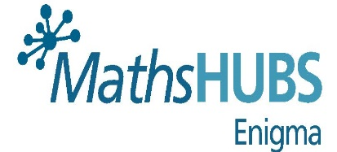
The Work Group Model

A lesson study approach is encouraged where all participants focus on a particular aspect of the maths curriculum and work collaboratively to develop this in their schools. Cross-phase classroom observation and discussion of practice is encouraged wherever possible.

Work focuses around a particular mathematical focus (multiplicative reasoning is used as the model but Work Groups are free to decide a different focus area if appropriate). Participants are expected to consider ways to develop the approaches with other staff in their schools. This will be evaluated by Work Group Leads against their plans and feed into the Lead Evaluator report.

Dates, venue and application forms out soon…

