NCP19-19: Challenging Issues at GCSE Workgroup
Four+ half-Friday sessions: 12 noon – 3:30pm
First session: Friday, 29 November 2019
Second session: Friday, 24 January 2020
Further Sessions: dates tbc
Course Leader: Ben Waine, Enigma Maths Hub

The three main English examination boards and the NCETM have met and, together, identified six key topic areas that have been proving challenging for students in recent GCSE sittings. Mathematics department leaders in our region have highlighted issues related to ratio & proportional reasoning as top priority.

The NCETM have then funded this workgroup as a rare opportunity for senior teachers in mathematics departments to gather, discuss, develop and assess new approaches to enhancing your own, your colleagues’ and your students’ responses to the more challenging aspects of the new mathematics GCSE; particularly up to grade 5.

It is one of many groups performing the same function across England between now and the summer 2020 GCSE sitting.

Who, from your team, is invited?

The Work Group will largely consist of pairs of teachers from up to half a dozen secondary schools. Ideally, each pair will comprise one teacher with a curriculum responsibility for mathematics and one other teacher, perhaps a non-specialist or RQT.

What is involved?

• During the year, it is suggested the Work Group should meet for
14-18 hours in total: at least four half-Friday sessions
• Participants will agree to focus on one challenging topic from the list
• Work Groups participants will develop, and share, teaching
activities and approaches designed to constructively impact KS4 students in the short, medium and long term

• Accordingly, Work Groups will also develop and share teaching activities for KS3 students which better prepare them for KS4; including adjustments to Schemes of Work
• Participants will evaluate (& share!) the success of the
activities and approaches
• Participants will receive feedback and approaches from the other Work Groups around the country

Intended outcomes

• Participant teachers develop deeper understanding of why certain topics are challenging (for both students & teachers) including factors associated with experiences in KS3
• Maths departments in participant schools, through
collaboration and experimentation, develop new and shared
ways of preparing for, and teaching, challenging topics
• Students become more confident in their own skills and abilities, developing a deeper and more connected understanding of prior content thus enabling them to better tackle and intervene with the challenging topics.

Expectations of participants and their schools

Participating teachers will be expected to:
• Share ideas and activities with others
• Reflect critically upon their own teaching approaches
• Trial a range of approaches, strategies and activities agreed upon by the Work Group and NCETM nationally

Maths departments in participating schools will be expected to:
• Support the participants by allowing them to trial activities and to disseminate findings at departmental meetings and with the NCETM and its member Hubs

Venue: Denbigh School, Burchard Crescent, Shenley Church End, Milton Keynes, MK5 6EX [within 40 minutes from most schools]
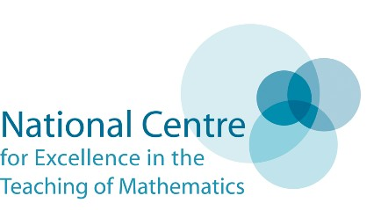
Examples from 2018-19:
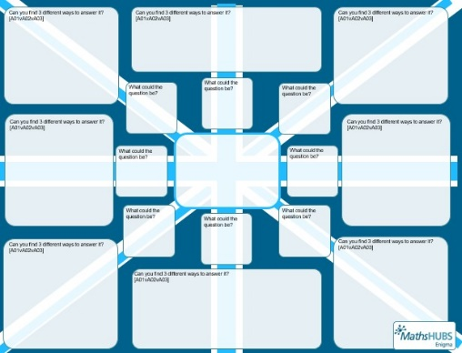
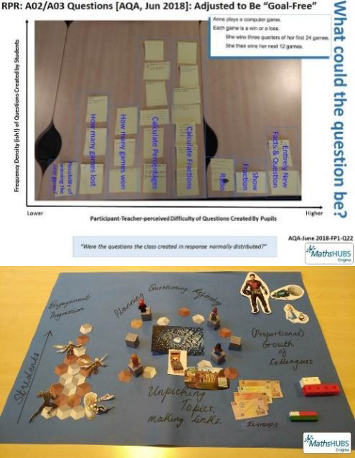
Ref: website for Challenging Issues at GCSE 2018-19

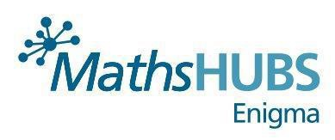
To book your place (and vote on topic) click this link: https://www.eventbrite.com/e/ncp19-19-challenging-issues-at-gcse-workgroup-tickets-80653933085
The Enigma Maths Hub, Denbigh School, Milton Keynes, MK5 6EX Call: 01908 330527 Email: enigmamathshub@denbigh.net

