Professional Development opportunities for 2020  Providing quality professional development across Bucks, Beds, Northants and MK  For further information and booking:  Call: 01908 330527  Email: enigmamathshub@denbigh.net  Visit: www.enigmamathshub.co.uk | 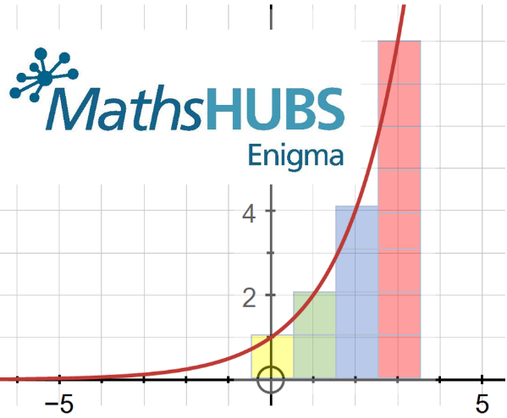
Primary Work Groups
Specialist Knowledge for Teaching Mathematics

To develop Subject Knowledge for Primary Teachers and Teaching Assistants to enable them to support and/or deliver mathematics in the classroom or in small intervention groups. This is a practical and engaging Work Group that delivers subject knowledge and associated pedagogy.
Participants might work in any Key Stage from Early Years to KS2.
Early Years: Supporting effective transition from Reception to Year 1
The intention of this Work Group is to support a whole school dialogue and consistency in message as to how best practice in EY feeds into the whole school Teaching for Mastery (TfM) provision. Currently the vast majority of TfM specialists are based in primary with limited EY experience. This Work Group would seek to ensure that good practice in the early learning of mathematics is fed into the KS1 provision (a bottom up rather than a top down approach). This Work Group will start with best practice in EY and ensure these principles guide the messages and make connections to the TfM model as and when appropriate. This overview has been put together as a starting point for discussions for school-based provision to support the whole school understanding of how best practice in EY links to a TfM approach in later years.
This project is primarily aimed at Reception and Year 1 teachers in schools that have adopted a TfM approach. Each school will need two participants, one from EY and one from Year 1.
Year 5 to 8 Continuity

This Work Group aims to improve communication between Key Stages 2 and 3 by taking an aspect of the mathematics curriculum or a pedagogical approach as the focus for the work.
Teachers from different phases work together collaboratively to develop a consistent approach to their chosen aspect through discussion, joint lesson design and delivery, observation and the development of documentation to support continuity. As a result, channels of communication are established and there is an increased focus on curriculum and pedagogical continuity at key transition points which supports children as they move from KS2 to KS3.
The participants will be a mix of teachers from secondary schools and primary schools, ideally where the schools are linked locally.

Teaching for Mastery (TfM)
The NCETM and Maths Hubs offer two different, funded professional development programmes in teaching for mastery. Both involve individual teachers and their departments working over time to embed mastery into maths learning. One involves a highly trained teacher supporting other schools to do the same. Schools that are already on their TfM journey with the NCETM will continue to be supported by mastery specialists and the wider TfM community. You will be contacted directly about the opportunities available in 2020/21 and beyond.
Secondary Work Groups
Year 5 to 8 Continuity
This Work Group aims to improve communication between Key Stages 2 and 3 by taking an aspect of the mathematics curriculum or a pedagogical approach as the focus for the work.
Teachers from different phases work together collaboratively to develop a consistent approach to their chosen aspect through discussion, joint lesson design and delivery, observation and the development of documentation to support continuity. As a result, channels of communication are established and there is an increased focus on curriculum and pedagogical continuity at key transition points which supports children as they move from KS2 to KS3.
The participants will be a mix of teachers from secondary schools and primary schools, ideally where the schools are linked locally.

Teaching for Mastery
The NCETM and Maths Hubs offer two different, funded professional development programmes in teaching for mastery. Both involve individual teachers and their departments working over time to embed mastery into maths learning. One involves a highly trained teacher supporting other schools to do the same. More information and FAQ are available on the flyer or from the NCETM website https://www.ncetm.org.uk/resources/52199
Applications for schools open 25 March
Applications to become a Teaching for Mastery Specialist open 11 March to 22 April 2020

Mathematical Thinking for GCSE

This Work Group offers teachers and their departments nationally coordinated support to address the reasoning and problem-solving challenges of the mathematics curriculum and its assessment in GCSE.
Mathematical thinking is central to deep and sustainable learning of mathematics.

Taught ideas that are understood deeply are not just ‘received’ passively but worked on by the student. They need to be thought about, reasoned with and discussed.

Mathematical thinking involves:
- looking for pattern in order to discern structure;
- looking for relationships and connecting ideas;
- reasoning logically, explaining, conjecturing and proving.

Challenging Topics at GCSE

The NCETM have funded this Work Group as a rare opportunity for teachers in mathematics departments to gather, discuss, develop and assess new approaches to enhance your own, your colleagues’ and your students’ responses to the more challenging aspects of the new mathematics GCSE; particularly up to grade 5.
Participants will:
- Review and improve the quality of T&L in a particular area of the curriculum, developing work through from KS3 into KS4 to improve outcomes at GCSE.
- Developing depth of subject knowledge and classroom practice.
- Lead improvement across the department.

In all Work Groups there is the expectation that participants will engage in research as part of their independent learning through the duration of the project. In addition to this there will be specific gap tasks set that set the expectation that there will be aspects developed in provision, enable a sharing of practice and allow for further developments to be made across the Work Group.

Supporting Post 16 GCSE

To help improve success rates for those resitting GCSE, this Work Group explores ways to make the student experience different. It considers which topics to focus on - and which to ignore - and ways of teaching to maximise impact in the limited teaching time.

Developing A Level Pedagogy

The demands of the new A level are explored in this Work Group. You gain a deeper understanding of the requirements of the specification and the overarching themes while developing others in your department.

Embedding A level technology

The new A level requires that the use of technology ‘permeates’ the study of maths and statistics. This Work Group explores practical approaches for integrating technology in the curriculum to enhance mathematical understanding. It also develops participants as technology champions in their own department.

Supporting Core Maths

This project consists of direct partnership working between the Maths Hubs Network and the Advanced Mathematics Support Programme (AMSP). The success of Core Maths depends in part on the growth of the pool of teachers, schools and colleges with the necessary expertise, experience and enthusiasm to teach it. This project will contribute to the wider national effort to grow that pool and embed Core Maths confidence and culture within school and college maths departments.
- Participants will understand the philosophy of Core Maths, with its approach to maths through contextualised problem-solving, appreciate the different Core Maths qualifications available and be able to choose the course appropriate for their students.
- Through collaboration and experimentation, participants will develop improved teaching approaches that fit the open-ended problem-solving skills students need to develop and also share these with departmental colleagues.
- Participant departments will support the role of Core Maths in promoting contextualised problem-solving and links to other teaching.
- Students in participant schools and colleges will take and succeed at Core Maths in increasing numbers.

Work Groups
The Work Group model is the professional development model unique to the Maths Hubs Programme.
Teachers from local schools come together and work on an area of maths teaching over a term or a school year. Most Work Groups meet together for three full of half days. The objective is for all teachers to develop professionally themselves and for them to be empowered to bring about positive change back in their school or department through gap tasks. This work then feeds back into the national programme.

See the NCETM website to find out more about the Work Group model https://www.mathshubs.org.uk/what-maths-hubs-are-doing/work-groups/

Local Leaders of Mathematics Education (LLME)
Accredited PD Lead Programme
NCETM-accredited Professional Development Leads: a year-long, maths and phase-specific developmental programme, leading to deployment as a Work Group Lead in a range of Maths Hubs projects.
National applications open 25 March to 5 May 2020

Teaching for Mastery Specialist Programme
Primary and Secondary Mastery Specialists. An initial development programme for current, school-based teachers, leading to deployment in later years supporting local schools as they develop teaching for mastery. This include PD lead accreditation in year 2 of the programme
Primary national applications open 27 April to 22 May 2020
Secondary national applications open 11 March to 22 April 2020 https://www.ncetm.org.uk/files/115826382/Secondary_Mastery_Specialist_Cohort_5_Info.pdf

SLE
Existing Specialist Leaders of Education (SLE): This programme aims to support existing mathematics SLEs in developing their approaches to maths school improvement work, including drawing on the expertise of approaches used in the Maths Hubs Programme such as teaching for mastery.
National applications open 25 March to 5 May 2020

Expression of Interest

To express an interest in any of the TfM or LLME programmes for September 2020 follow this link: https://www.ncetm.org.uk/resources/54269

To express an interest in any of the other Work Groups for September 2020 follow this link: https://forms.gle/8wU9xaPKLsnGp4mY7

Not found what you need?
Enigma Maths Hub also run new Innovation Work Groups every year. These Work Groups are planned addressing local needs. In the past we have had Work Groups looking at bar modelling in Primary, using manipulatives in Secondary and mathematical resilience. If you have an idea for a Work Group please contact websterj@denbigh.net.

Throughout the year we hold conferences and open sessions. We will keep you up to date on all events through our termly newsletter.
Thank you for continuing to support the work of the Enigma Maths Hub.
We are constantly working on developing and increasing our network of maths teachers and Local Leaders of Maths Education - please share this with colleagues and encourage them to contact Enigma Maths Hub so that they can join our mailing list and take part in the latest research and evidence based events and projects.
We look forward to working with you. Enigma Maths Hub Team

