Work Group Purpose
Feedback from teachers and GCSE exam analysis indicates there are key areas of the curriculum that students continue to find challenging.

While teachers will need to address students’ immediate difficulties with regard to such topics, there is also the recognition that these issues are often rooted in earlier learning, and this forms a key focus for these Work Groups.

These Work Groups address strategic goals relevant to secondary schools, specifically: supporting schools to address the challenges of teaching GCSE Mathematics so that all pupils develop deep knowledge, understanding and confidence, and are well prepared for progression to post-16 education.

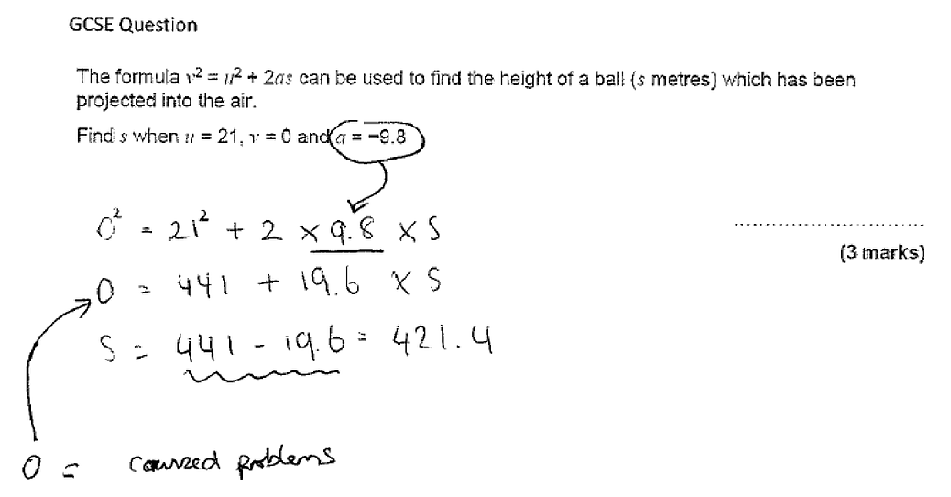
Identifying common misconceptions 2019

Challenging Topics at GCSE

This project focuses on participant teachers working together to ‘unpick’ (i.e. analyse, deconstruct and trace through the curriculum) a challenging topic, developing insight into the associated difficulties and misconceptions to support teaching in the short term but also considering the implications for longer term curriculum design.

Work Groups will follow a workshop – school-based task cycle, consisting of several workshops followed in each case by a specific school-based task. Workshops will provide opportunities for teachers to identify and analyse a key challenging topic area, to work collaboratively to develop pedagogical approaches to it, and to evaluate and discuss after teaching.

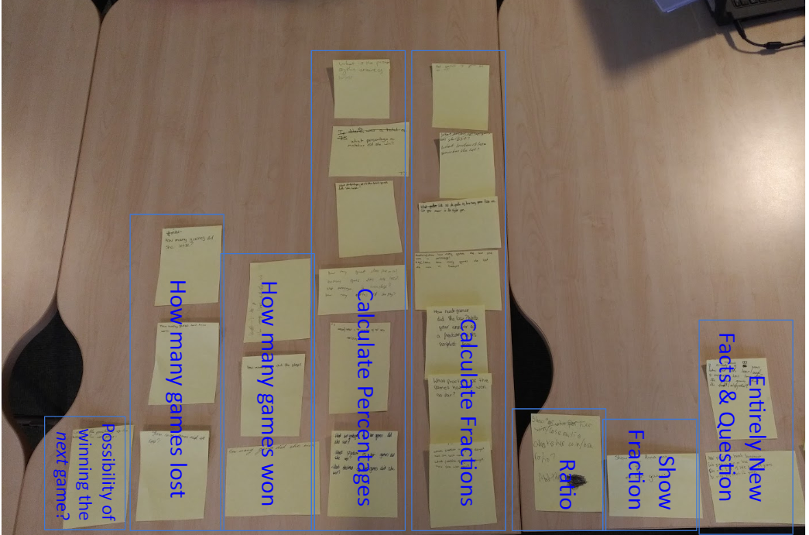
Analysis of Goal Free Problems 2019

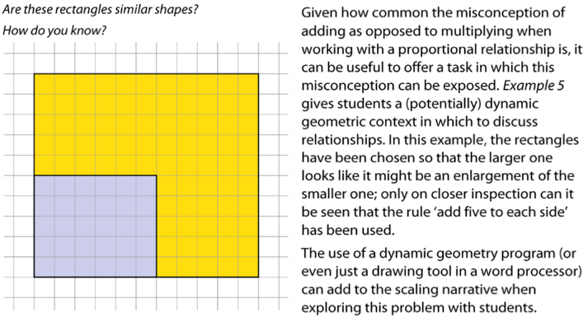
NCETM PD material

Who should apply?

Each Work Group should consist of at least four schools, ideally with two teachers attending from each school.

Dates, venue and application forms out soon…

