Year 8
Mastering Ratio
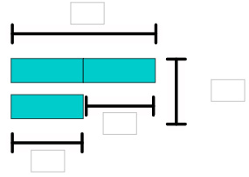
Name:

A bakery bakes small, medium and large pies.
The ratio small : medium : large is 3 : 5 : 2.
What fraction of the pies are large?
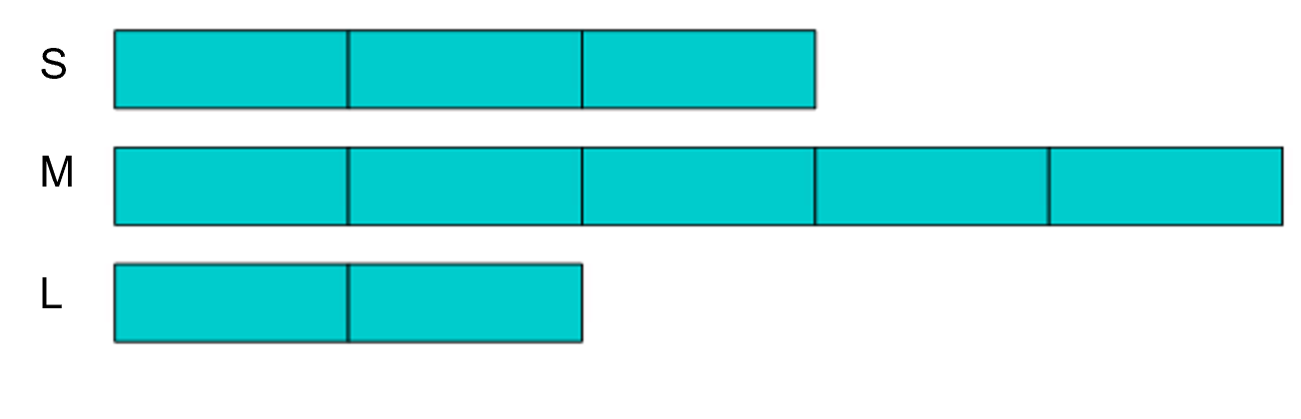
One day 460 medium pies are baked.
Work out how many small pies are baked

The workers in a company are in the ratio female : male = 1 : 5
What fraction of the workers are female?

The company has 150 female workers.
How many workers are there altogether?

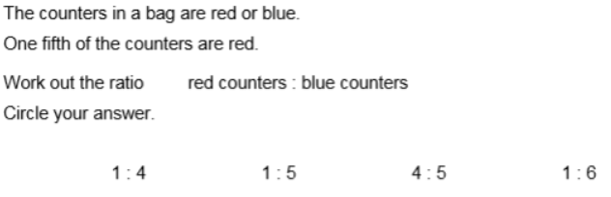
Circle the correct model

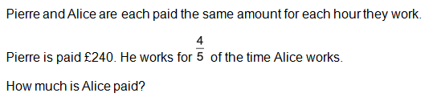

A box contains 192 pens,
They are red, green or blue.
A quarter of the pens are red.
The ratio green pens : blue pens = 1 : 8

How many blue pens are there?

