Year 9
Mastering Ratio
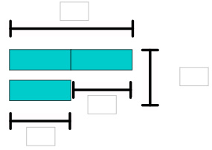
Name:

Ratio Rods
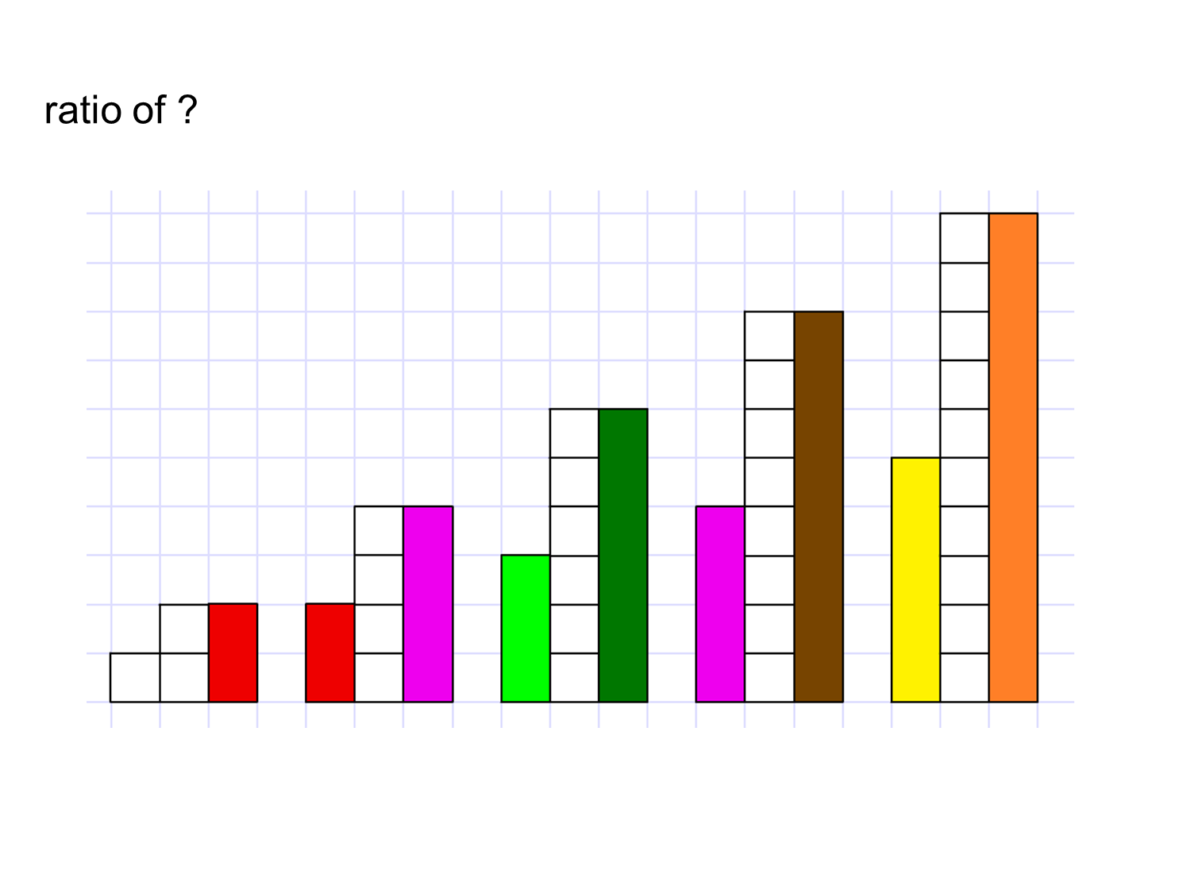

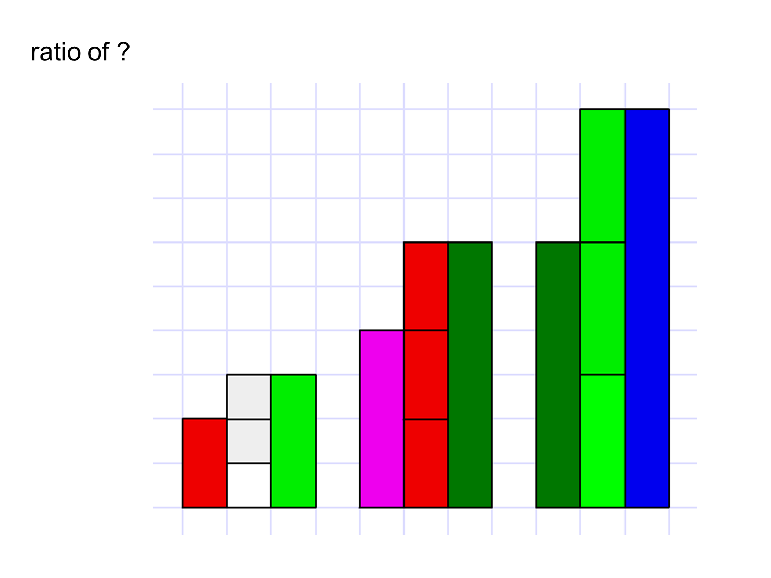
What are equivalent ratio’s?

Comparing Ratio
Which of the following will be orangier when they are shaken up? Show your working on the next page.
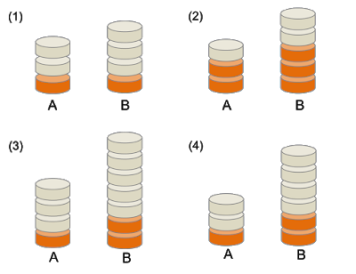
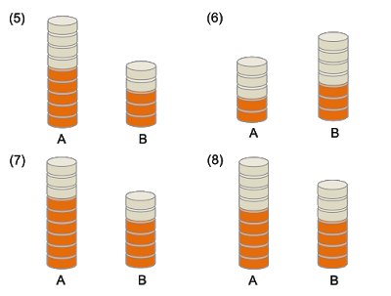

Comparing Ratio
a:b = 3:4
b:c = 4:7
a:c =

a:b = 3:4
b:c = 8:14
a:c =

x:y = 3:4
y:z = 8:5
x:z =

m:n = 3:5
n:p = 10:7
m:p =
a:b = 3:4
b:c = 12:5
a:c =

a:b = 3:5
b:c = 15:7
a:c =

a:b = 3:2
b:c = 8:5
a:c =

a:b = 3:5
b:c = 20:9
a:c =

a:b = 3:4
b:c = 5:7
a:c =

a:b = 3:2
b:c = 5:4
a:c =

a:b = 2:5
b:c = 3:8
a:c =

a:b = 4:7
b:c = 3:8
a:c =

Ratio Problems
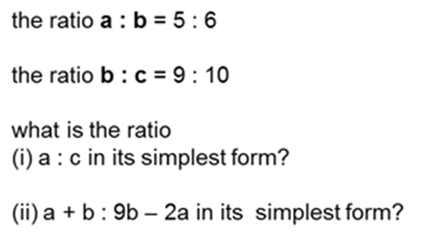

Compare and Share Ratio
Lia, Dan and Sam share counters such that:
The ratio of Lia to Dan is 7:5
The ratio of Dan to Sam is 2:3
Given Lia has 56, how many does Sam have?

L
D
S

Key Question 2
Bob, Max and Lee share counters such that:
The ratio of Bob to Max is 1:2
The ratio of Max to Lee is 3:5
Given Bob has 9, how many does Lee have?

Key Question 1
A bakery bakes small, medium and large pies.
The ratio small : medium : large is 3 : 5 : 2.
What fraction of the pies are large?
One day 460 medium pies are baked.
Work out how many small pies are baked

