
Maths Hubs Innovation Projects 2019/20
Exploring Teaching for Mastery

IN 19-03

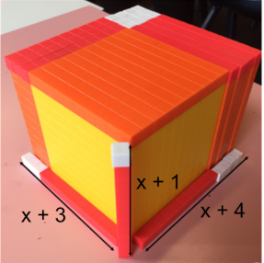

What will you gain from it?

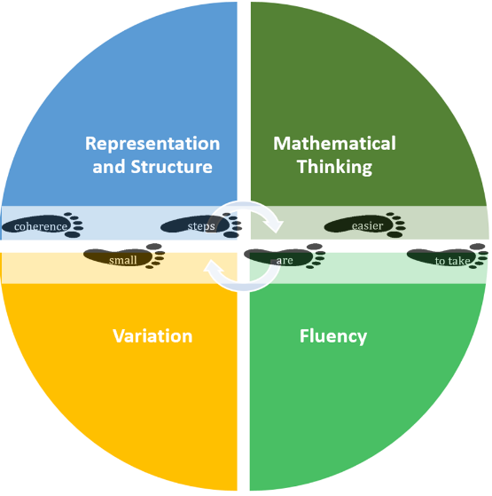
You will develop a deeper understanding of principles and practices of teaching for mastery including the 5 Big Ideas – representation and structure, variation, mathematical thinking, fluency and coherence.

Plan lessons using conceptual and procedural variation.

Use manipulatives and online interactive tools to uncover representation and structure.

Look at the KS2 and KS3 curriculum and consider curriculum planning.
Pupils will begin to develop a deep, secure and connected understanding of the mathematics they are learning, achieve both conceptual understanding and procedural fluency at each stage of their learning and see mathematics as a subject which is interesting, stimulating and enjoyable.

Participants will attend 4 twilight sessions with classroom-based gap tasks:
Workshops 1 and 2 will focus on teaching with variation.
Gap Task: Plan and deliver a lesson using variation and bring feedback to Workshop 2.
Workshops 3 and 4 will focus on representation and structure.
Gap Task: Use manipulatives or online interactive tools to teach a lesson based on uncovering representation and structure.

Each Work Group needs a minimum of 6 schools with up to two teachers from each school. Venues can be arranged locally. If you are interested in this Work Group please email websterj@denbigh.net and include subject: Exploring TfM

