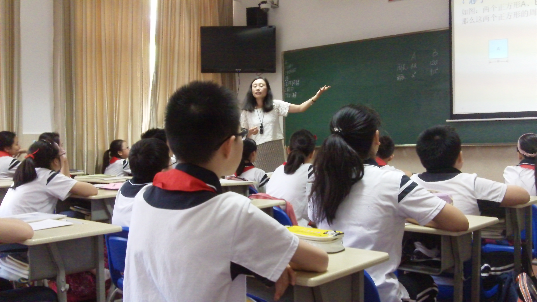

Shanghai 2015 video playlist
https://www.youtube.com/playlist?list=PLc-Yti0Fks-HahZegJb_PJTHKssk-KBtI

