Bar Modelling Handbook
Primary to GCSE

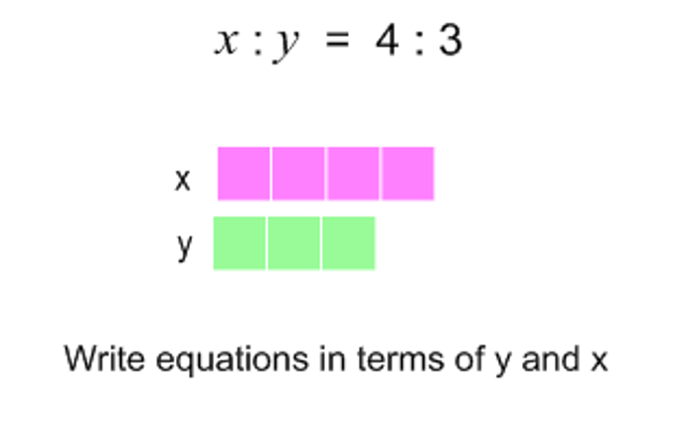
Bar Modelling
The bar can be a valuable representation to enable students to represent problems in such a way that the mathematical structure is exposed.
This enables students to ‘see’ the problem clearly and to then recognise the strategy they need to solve the problem.
NCETM
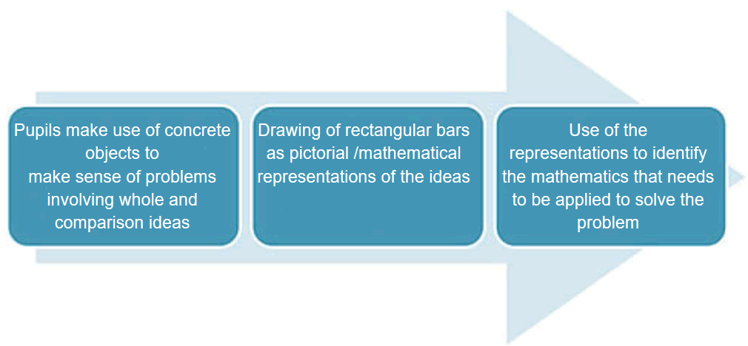
Avoid the common mistakes! Do not jump straight into the pictorial representation.

Concrete Pictorial Abstract

It is important to go through all the stages from concrete to pictorial to abstract at the start so that students can make sense of the problem and build up from something concrete to an abstract method that they can use fluently.

ALL STEPS ARE IMPORTANT

Primary example from White Rose
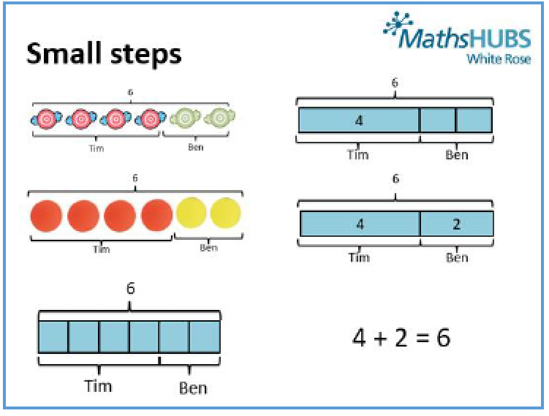
Tim has 4 sweets and Ben has 2 sweets.

How many sweets do they have altogether?

Maths No Problem – One of the recommended Primary Mastery Textbooks
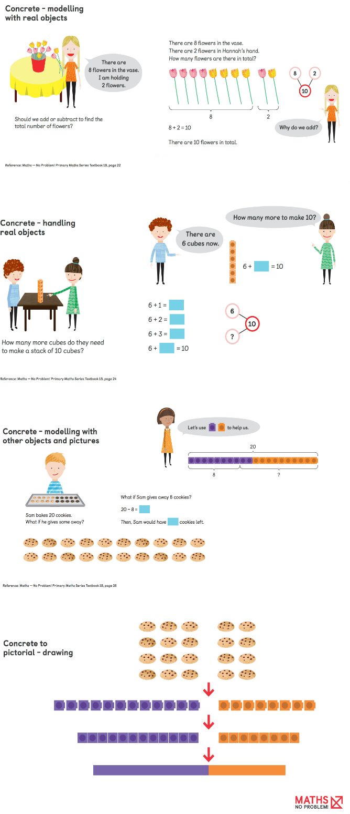
https://mathsnoproblem.com/en/mastery/bar-modelling/

Concrete – real life objects

Concrete – handling real objects (manipulatives)
blocks, cuisenaire rods, counters etc

Concrete – bar model

Real – manipulative – bar model

In later KS3 and 4 examples we will look at developing fluency by moving from bar model to abstract- calculation and abstract – algebra
Consistency
https://www.teachwire.net/news/8-mistakes-schools-make-teaching-the-bar-model-method-in-maths
Teachers from over 10 schools were asked to model 140 – 96. A variety of responses were given.
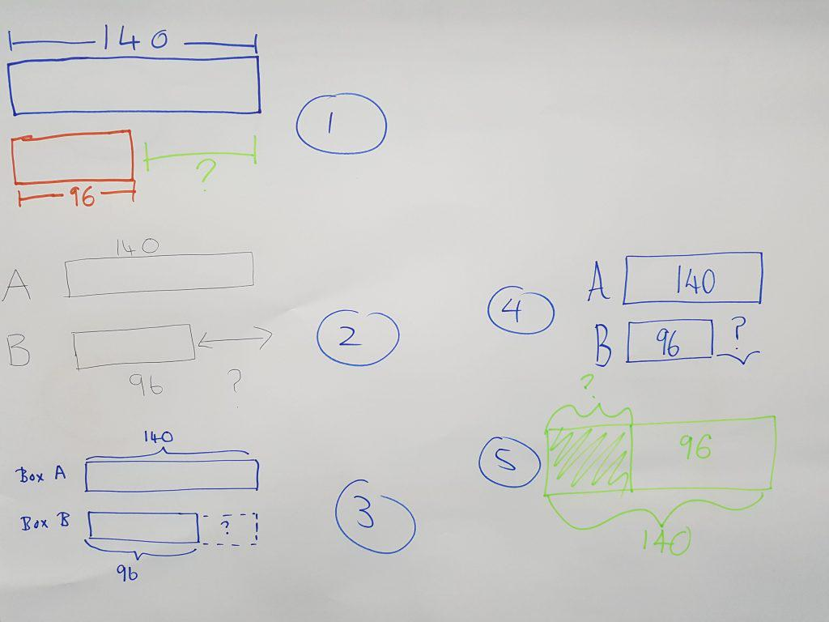
A consistent approach will always result in a more efficient use of bar models throughout the school and lead to fewer pupils being confused and fewer mistakes from both teachers and pupils.
What differences can you see?

What difference does it make?

Which model would you go for and why?

Choosing the correct model
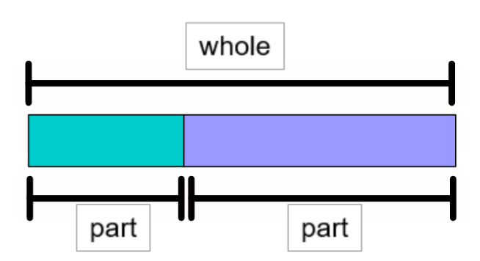
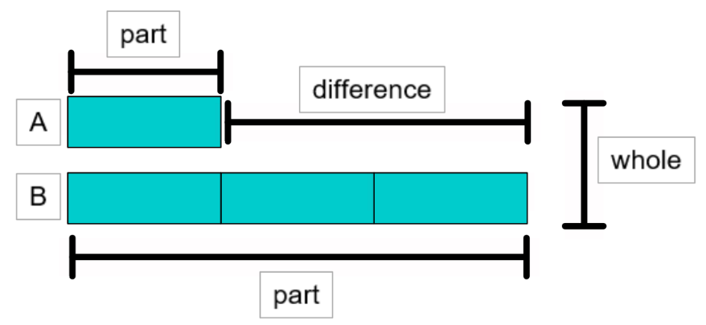
Part Whole Model Comparison Model

Can you think of three different questions to go with each model?

Part Whole Model
https://www.mathplayground.com/tb_fractions/index.html
Kayla bought 7/10 of a gallon of blue paint. She used ½ a gallon to paint the shed. How much blue paint did she have left?
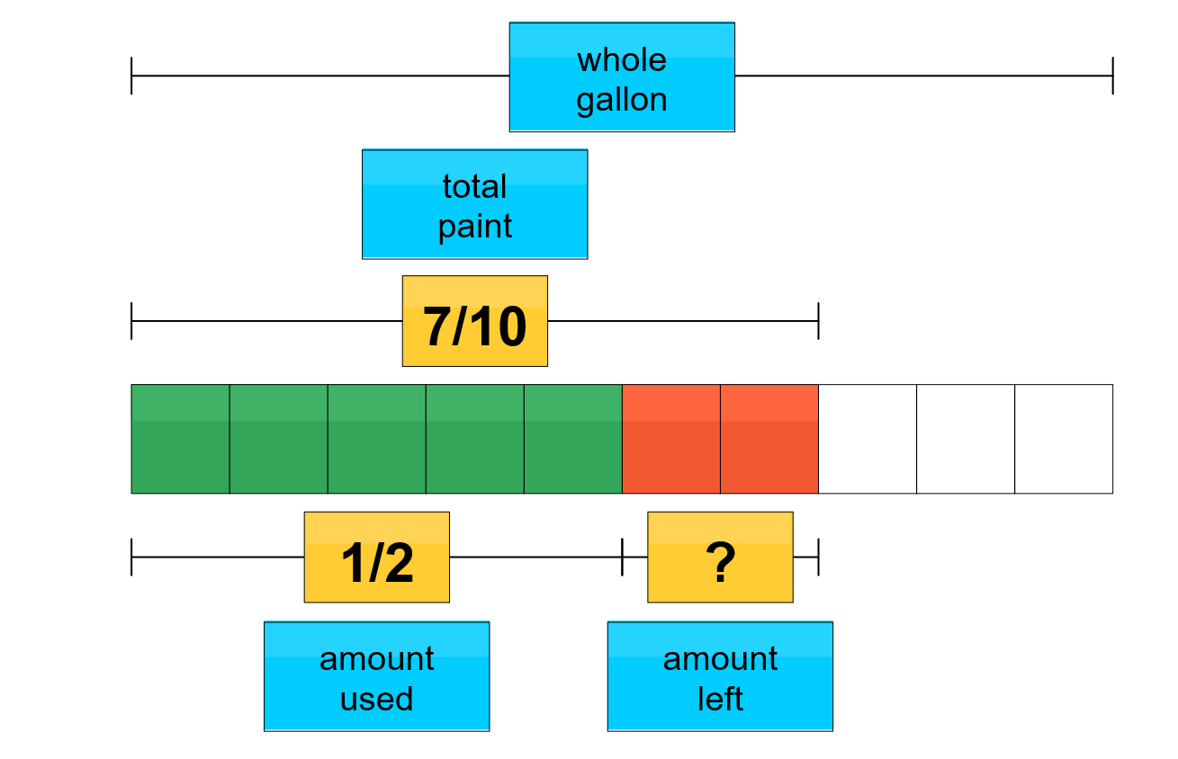

Comparison Model
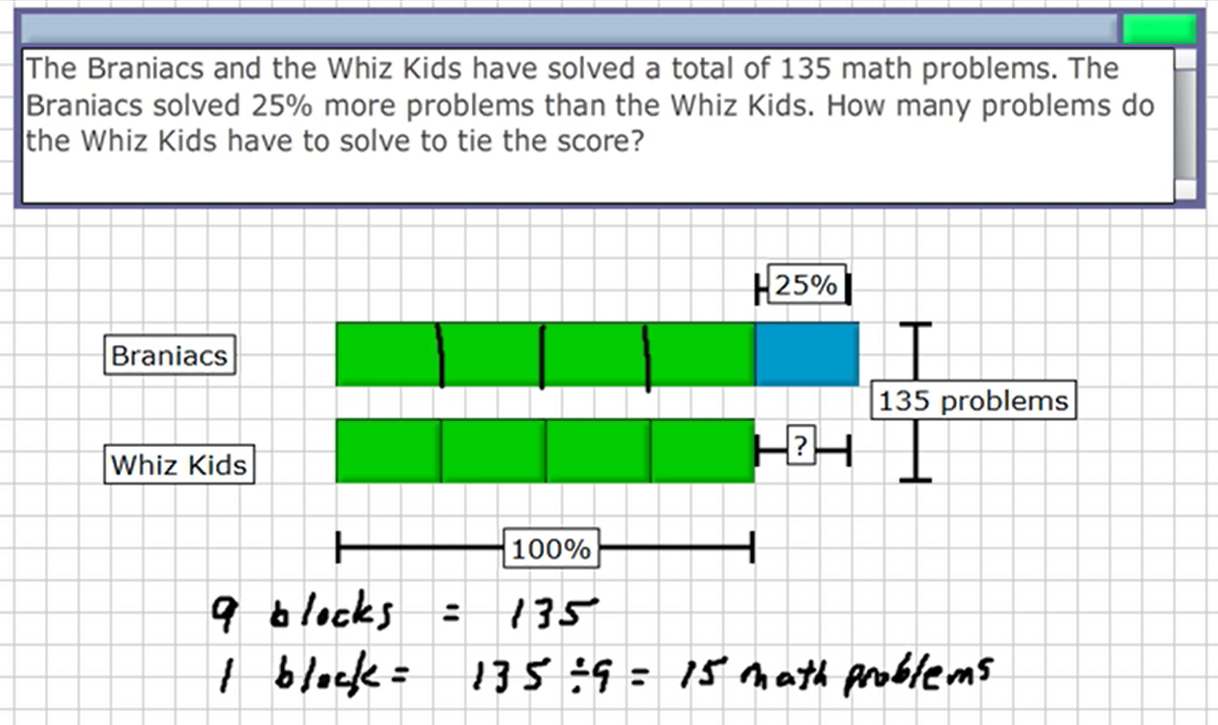
https://www.mathplayground.com/ThinkingBlocks/thinking_blocks_decimals_percent_5.html

Thinking Blocks on mathplayground has a wide variety of interactive problems for students to try along with videos and a modelling tool.
Ratio Question(s) – Introducing the bar model
Alfie and Billy go crabbing. Each bucket holds the same number of crabs. Alfie has one bucket and Billy has 3 buckets. If Alfie has 3 crabs, how many crabs does Billy have?
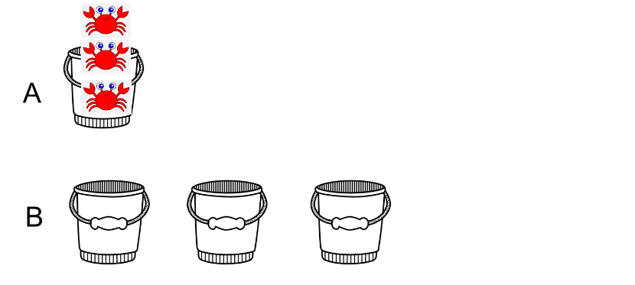
Concrete - real

Step 1: Get students to use plastic cups and counters to model this.
Step 2: Model using counters
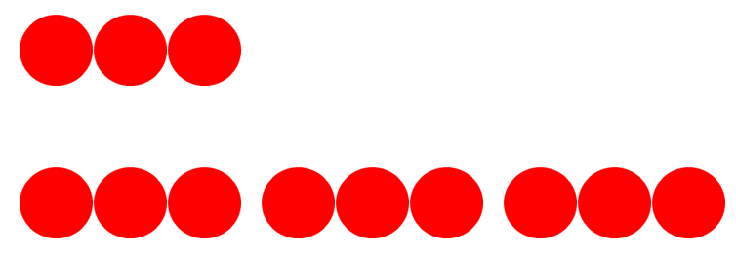
A
Concrete - manipulatives

B
Abstract -algebra
Abstract - calculation
Step 3: Model using bars
Pictorial – bar model
1 block = 3 b = 3

3 blocks = 3 x 3 = 9 3b = 9
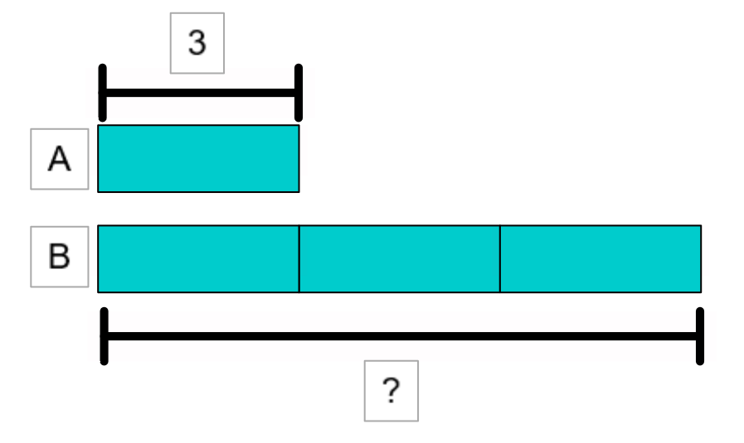
Ans: Billy has 9 crabs

Try these questions using CPA.
Billy has 15 crabs. How many crabs does Alfie have?
There are 28 crabs in total. How many crabs does Billy get?
Billy has 20 more crabs than Alfie. How many crabs are there in total?

When students are familiar with bar models you can start with the bar model and move on to develop fluency with abstract calculations and algebra.
Percentage Question(s) - From bar model to box model
(Van Hiele, proportion matrix, ‘Structure and Insight’ (1986), chapter 28) and https://drive.google.com/file/d/19OsyPhuoKM_16rEV1cZmOHKLpNUG5WnX/view - Don Steward - Median)
What is 20% of 160?
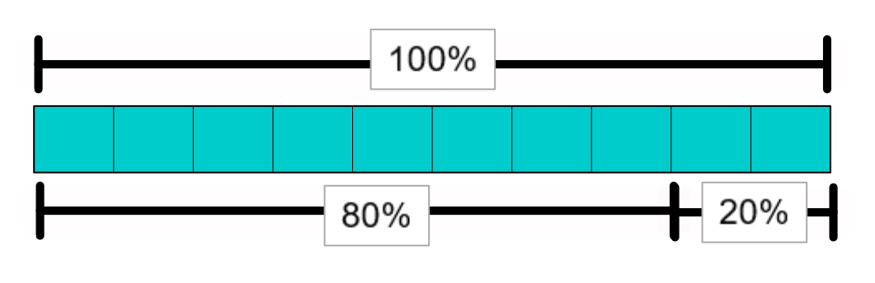

100% 160

20%

Start with single step problems and then move onto two step problems.

What is 80% of 160?
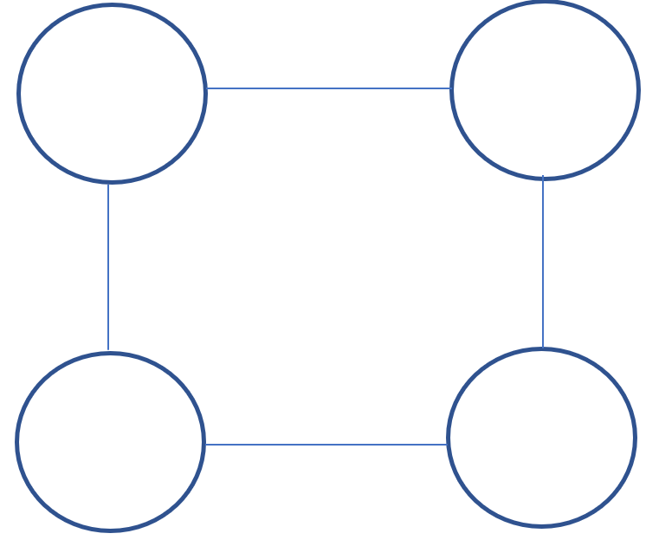

20% of a number is 160. What is the number?

Start with single step problems and then move onto two step problems.

80% of a number is 160. What is the number?

From here you can introduce the unitary method:

12% of a number is 480. What is the number?

SSDD Questions https://ssddproblems.com/
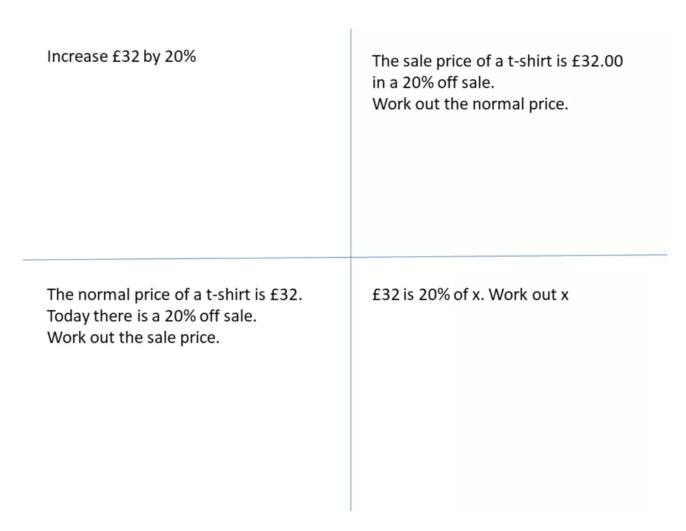
A good same surface, different depth question uses the same numbers but different questions. This highlights the difference in the questions. This is a great example of variation.

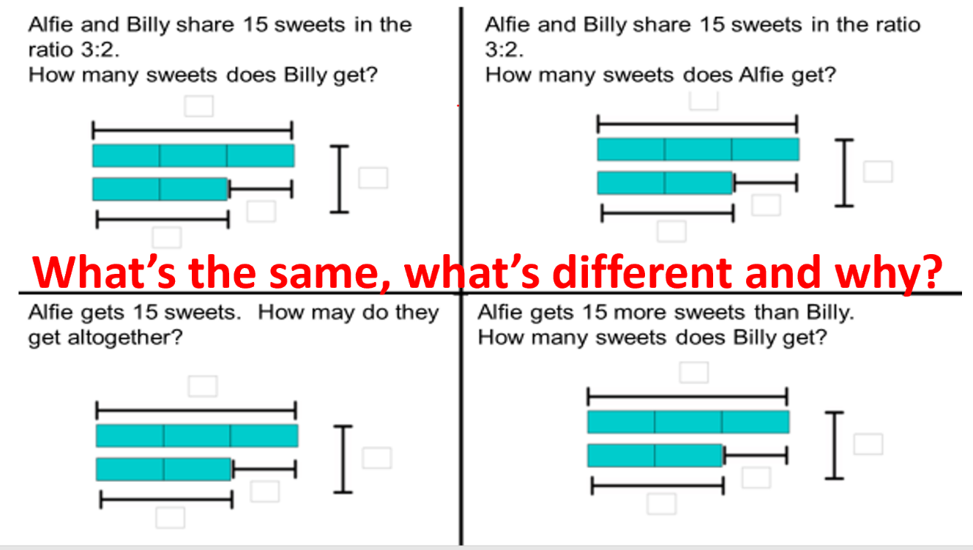
Try the following NCETM (adapted) problems using bar models.
Choose the correct model - Annotate the model – Calculation - Algebra

Year 6 Problems
- Three quarters of a number is 54. What is the number?
- There are 36 packets of biscuits. One half are chocolate, a ninth are digestive and a third are wafer biscuits. The rest are ginger nuts. How many biscuits are ginger nuts?
- There is 20% off in a sale. How much would a track suit cost, if the normal price was £44.50?
- There is 20% off in a sale. The reduced price of the jeans is £36. What was the original price?
- At a dance there are 4 girls to every 3 boys. There are 63 children altogether? How many girls are there?
- Seven in every nine packets of crisps in a box are salt and vinegar. The rest are plain. There are 63 packets of salt and vinegar crisps. How many packets of plain crisps are there?

Key Stage 3 Problems
- Ralph posts 40 letters, some of which are first class, and some of which are second class.
He posts four times as many second class letters as first.
How many of each class of letter does he post? (This question appeared on a GCSE higher tier paper.)
- A computer game was reduced in a sale by 20% and it now costs £55 What was the original cost?
- Sally had a bag of marbles. She gave one-third of them to Rebecca, and then one quarter of the remaining marbles to John. Sally then had 24 marbles left in the bag. How many marbles were in the bag to start with?
- Sam bakes a variety of biscuits.
13 are peanut, 12 are raisin, the remaining 5 were oat. If you choose 1 biscuit at random, what is the probability that you will get an oat biscuit?
- Tom spent 30% of his pocket money and put away 45% into his savings. He was left with £2.50. How much pocket money did he receive?
- Two numbers are in the ratio 4:5. They both sum to 135. Identify both numbers.
- Two numbers are in the ratio 5 : 7. The difference between the numbers is 12. Work out the two numbers.
- A herbal skin treatment uses yoghurt and honey in the ratio 5 : 3. How much yoghurt is needed to mix with 130 g of yoghurt?

AQA GCSE Exam Questions
Part whole
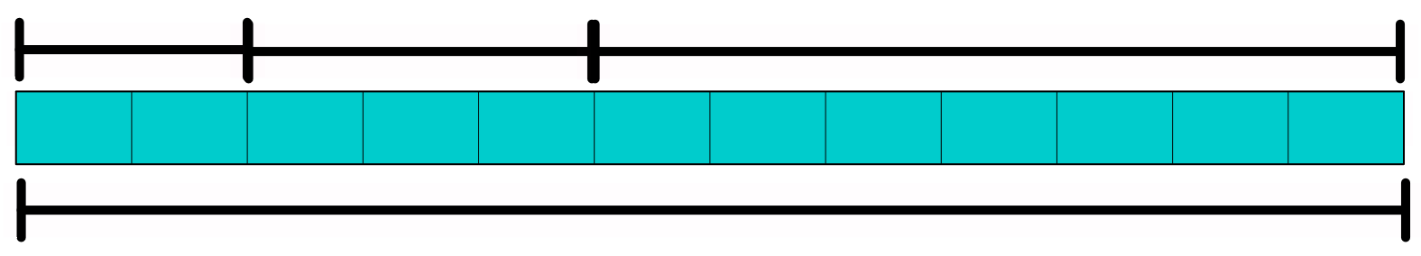
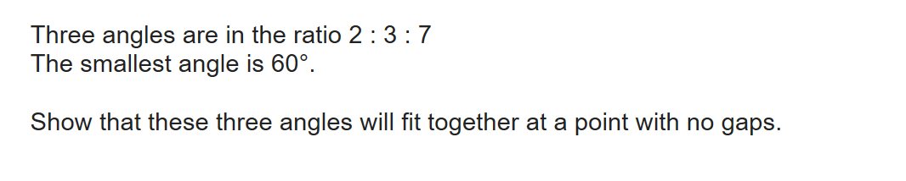
°
°
°
60°

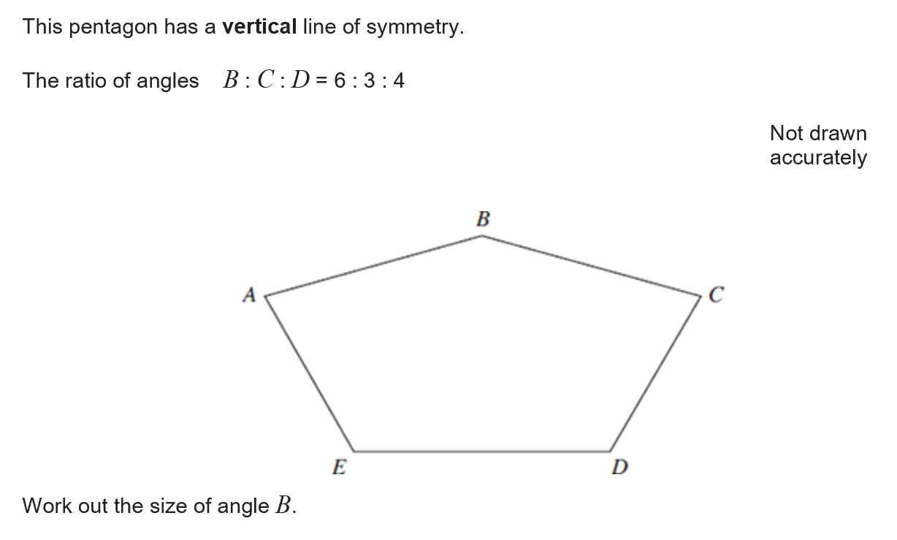

Comparison
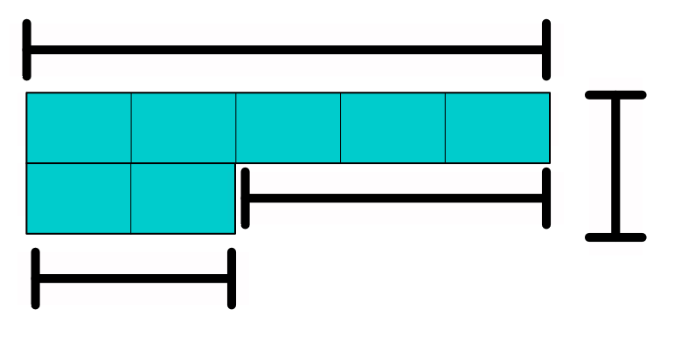
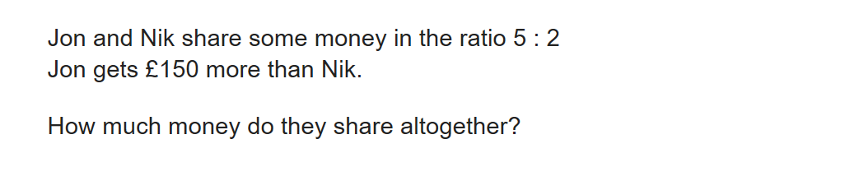

?
150
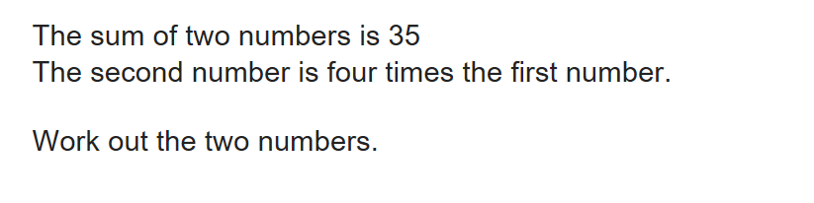

Comparison and part whole
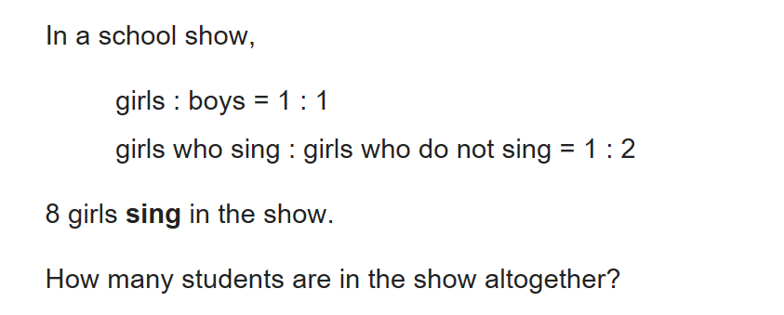
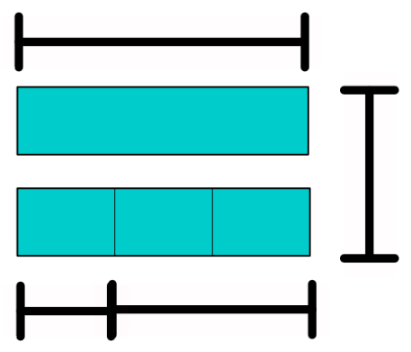

?
8

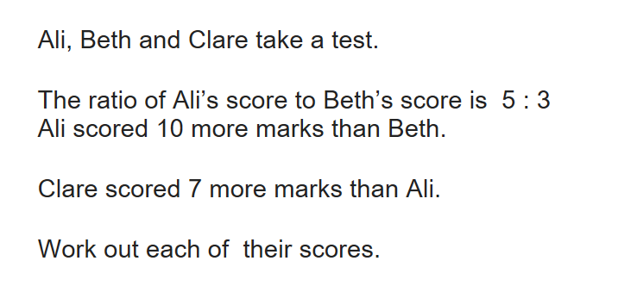

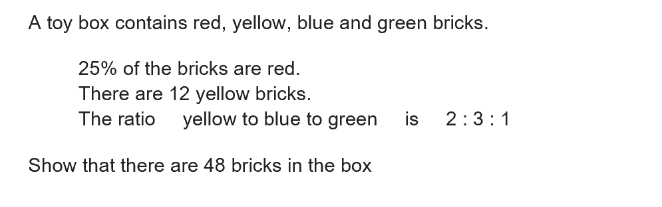

Comparison and fraction/percentages
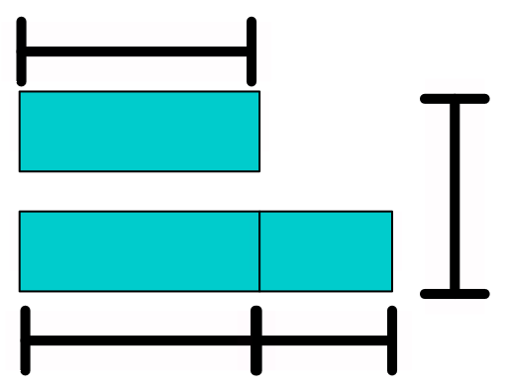
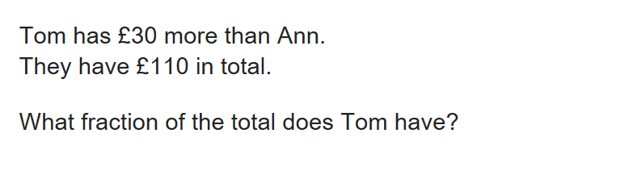
110
30
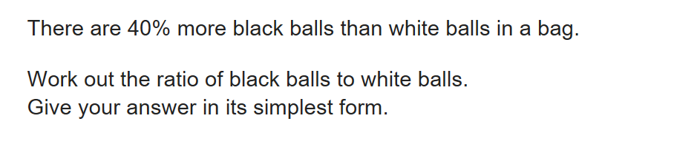

Comparison and equivalent fractions
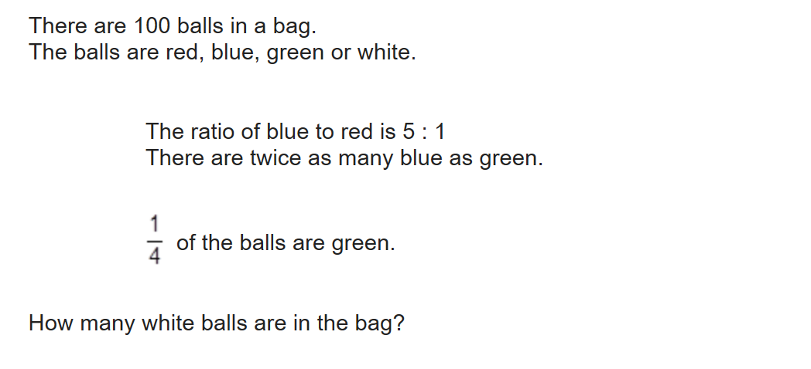
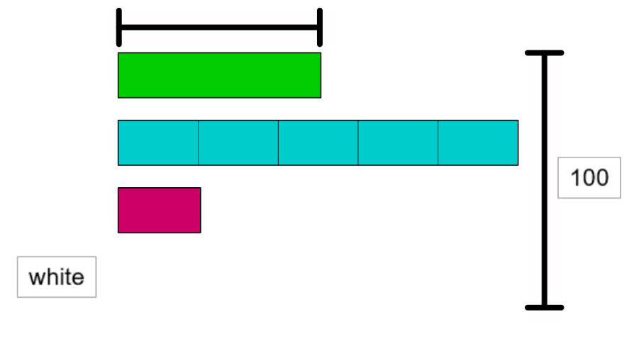
1/4
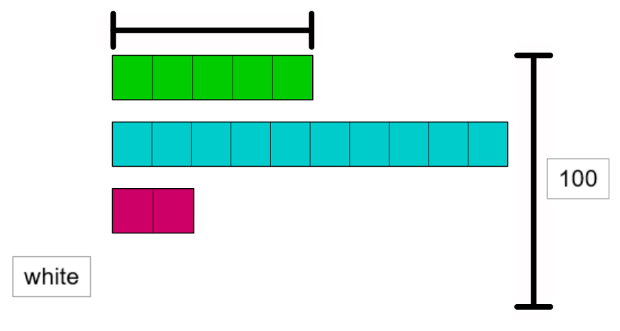
25
Comparisons with changes
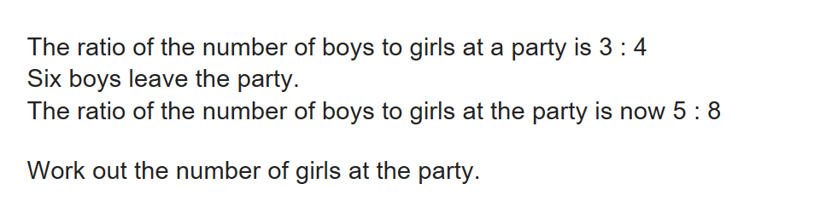
Before change
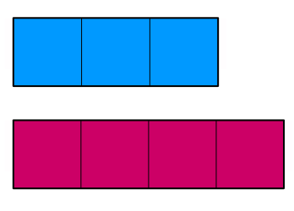
After change
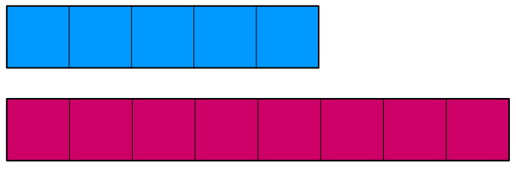
Number of girls remains the same. To compare like for like change 3:4 to 6:8
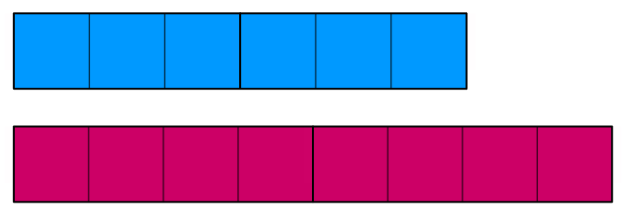
6
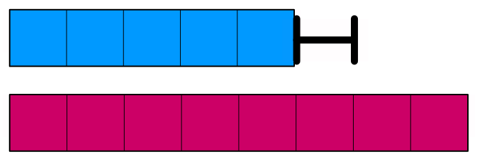

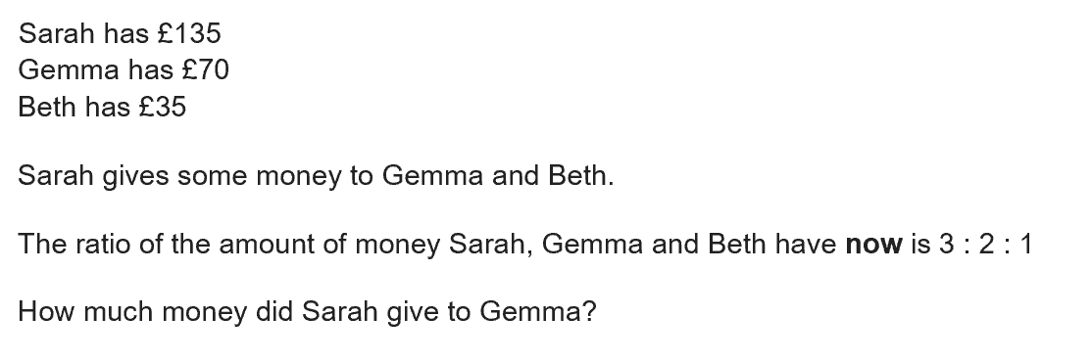

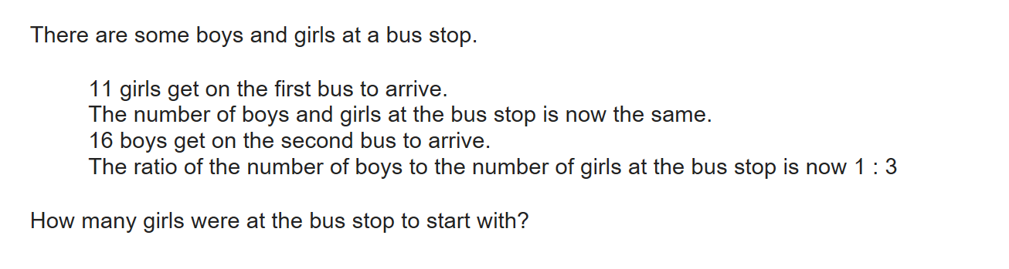

Compare a:b to b:c
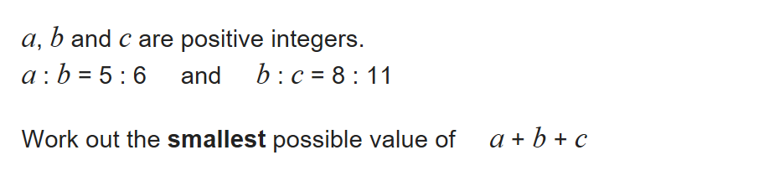
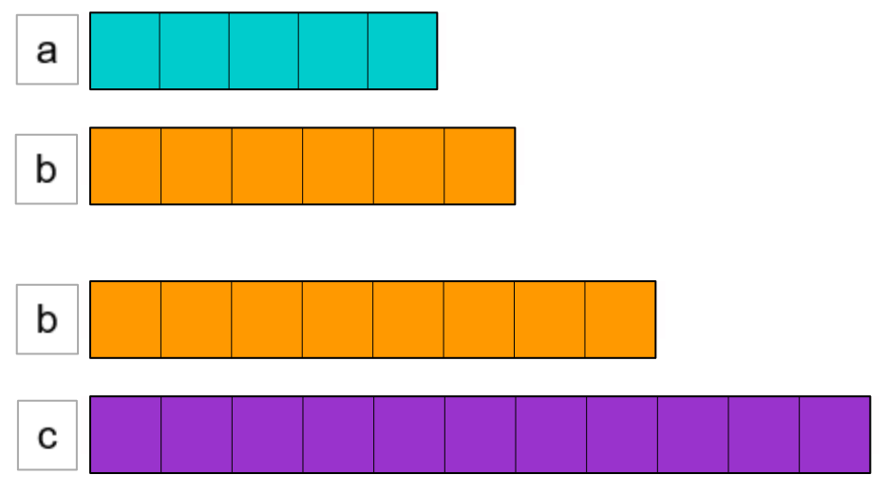
To compare like for like b must be the same length (LCM).
5 : 6 and 8 : 11
20 : 24 24 : 33
a + b + c = 20 + 24 + 33 = 77

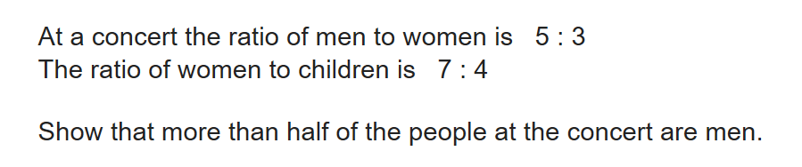
m : w 5 : 3 35 : 21
w : c 7 : 4 21 : 12

m : w : c = 35 : 21 : 12

35 are men 51.5% are men
68
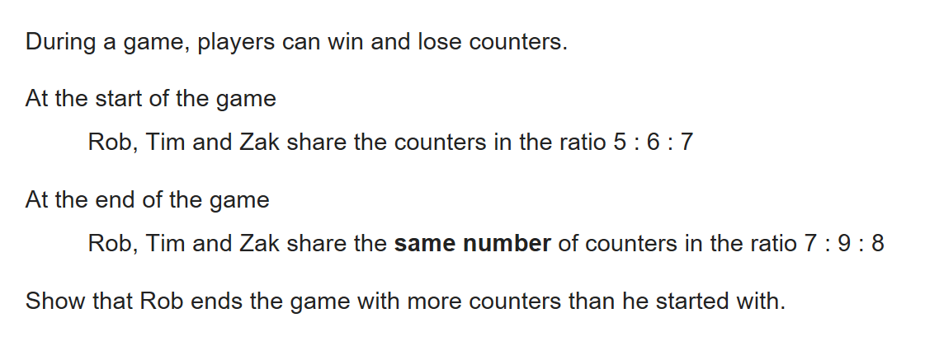
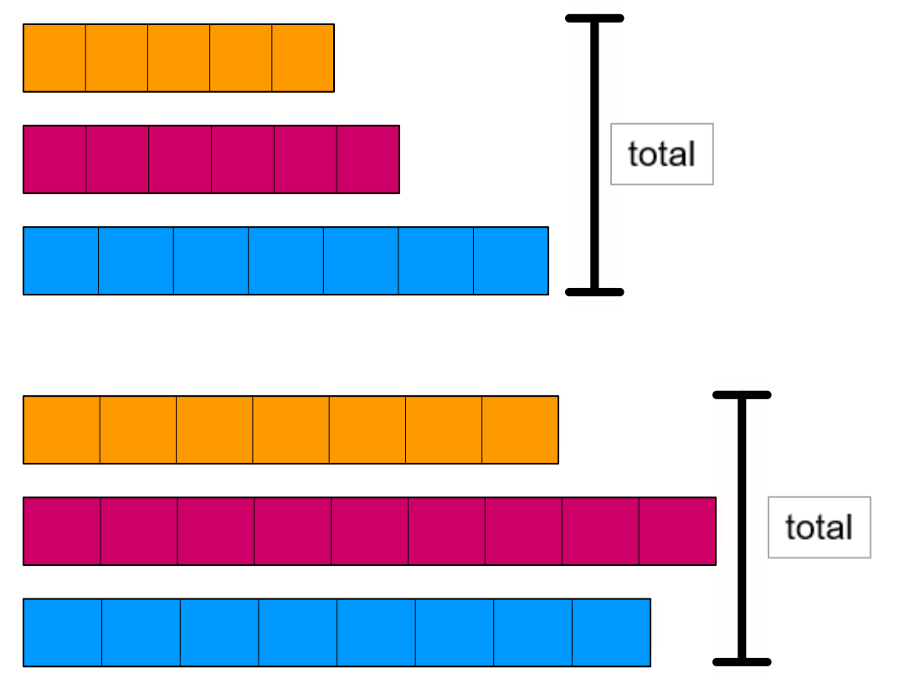

5 : 6 : 7 18 blocks
7 : 9 : 8 24 blocks
The total number of blocks needs to be the same. LCM of 18 and 24 is 72
20 : 24 : 28 72 blocks
21 : 27 : 24 72 blocks
Rob ends with one more block

1:n and n:1
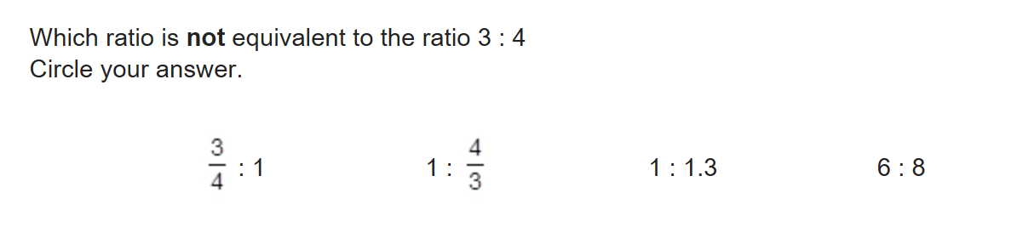
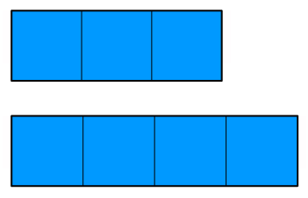
Should be 1.333333333333…

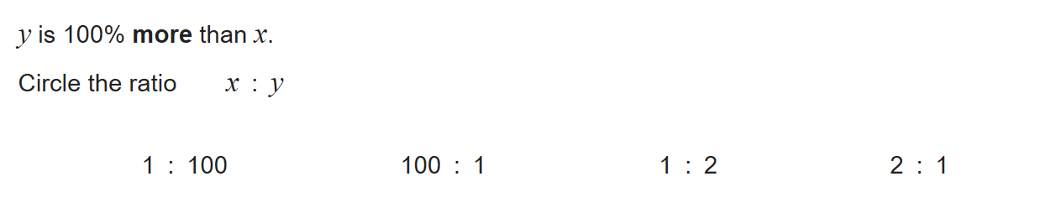

x:y = a:b to fraction
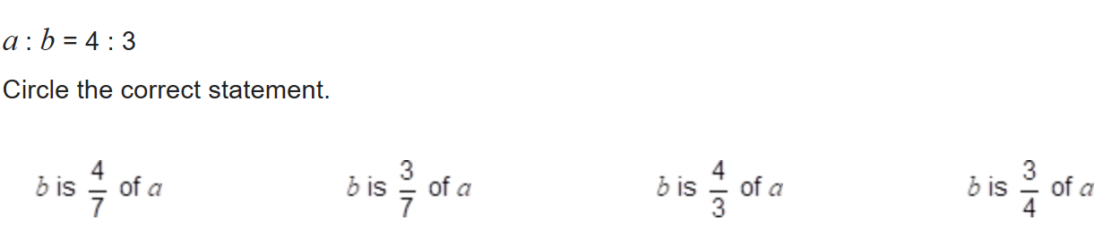
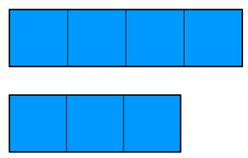

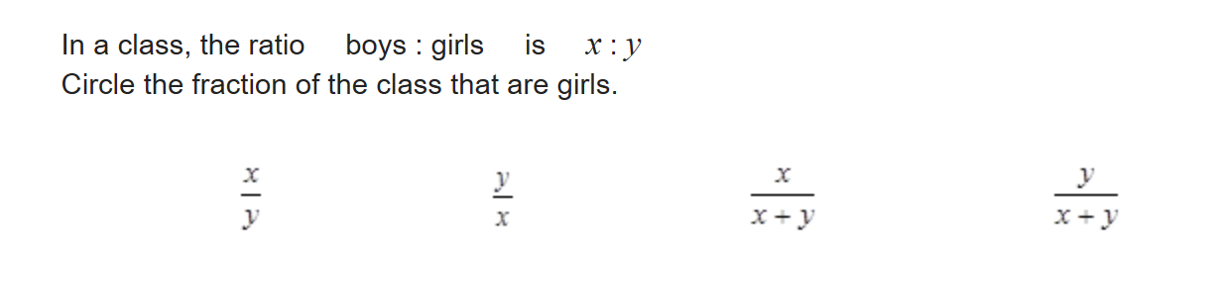
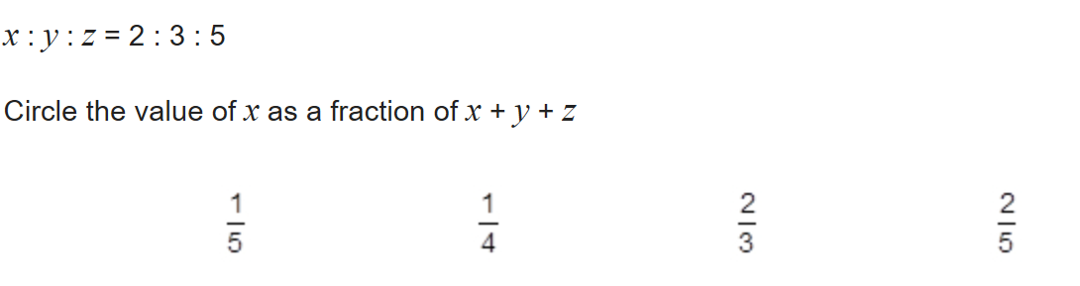
x:y = a:b to equation
Write as many equations as you can connecting r and g.

r = 2/3g

g = 1.5r g = 3/2r

3r = 2g

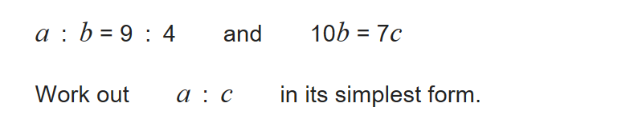
If 10b = 7c, b:c = 7:10
a : b 9 : 4 63 : 28
b : c 7 : 10 28 : 40

a : c = 63 : 40

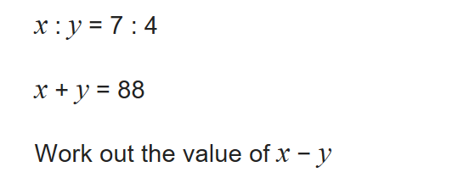
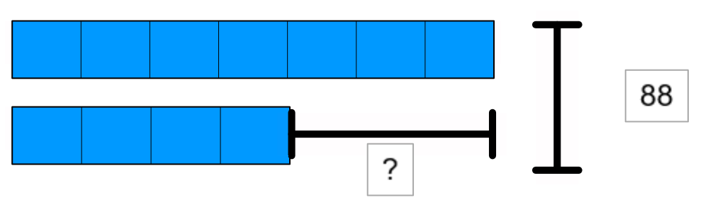

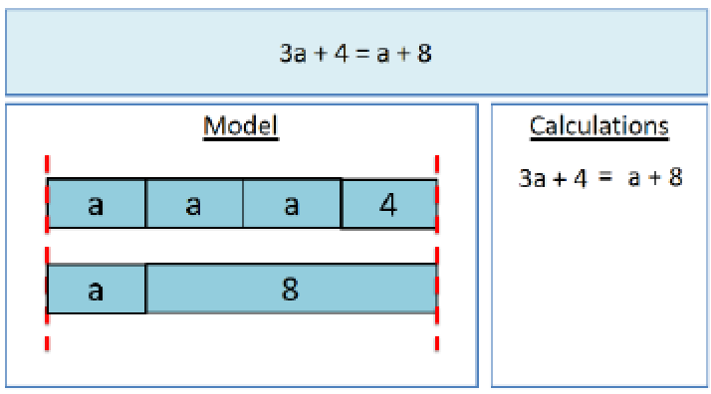
Is a bar model always the most appropriate model?

Now draw a model for 3a – 4 = 8 – a

3a – 4 = 8 – a

More resources and the latest professional development details available on https://www.enigmamathshub.co.uk/
